Mission parameters

Tutorial Mission:

The tutorial mission serve as the entrance to the player to the game world. In the tutorial mission we introduce the player to the command mechanics as well as basic attacks. We do so by allowing the player to utilize the basic commands to various troops in an empty area to show them what verification of visual feedback looks like.

* On Screen prompts of what to do
* small stage demonstrating how to do commands in terms of grab and pull with prompts with buttons and text giving the player text confirmation of what they are doing through their various buttons and command prompts
* Possibly do it in cutscene to demonstrate to player what to do.

Cutscene Drafting:

* Victory or defeat sweep over demonstrating the troop win or loss animation and zoom around map showing what the player did.
* Locations needed to attack, strongholds, break magical seals-Temple
* Fortresses and Villages
* Villages- Ransacking village,houses, destroying, neutralize personnel, limited troop count vs populace

Village Mission:

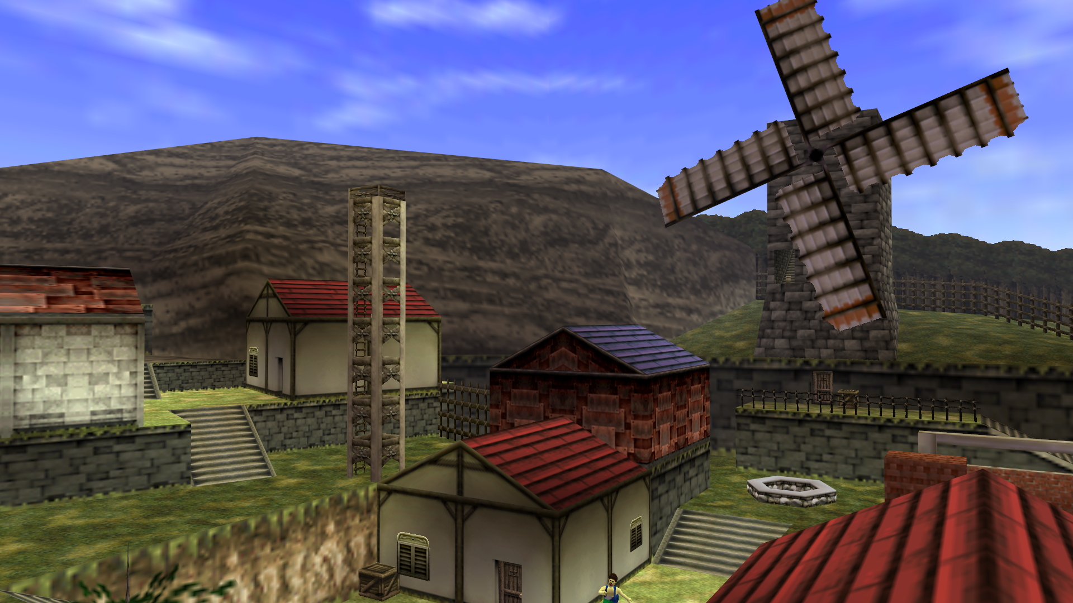

The village missions entail raiding various houses. As well as fending off warriors and destroying as much of the village as possible or choosing to keep it intact for after the player takes control. Once the player takes control of the village they can use it as a hub for part of their commands and train or recruit further troops. Village objectives serve as killing, capturing, oppressing as many citizens and warriors as possible to lead to chaos.

* Kill warriors and offensive protecting town to lower their morale and troop count
* Destroy their village to lower town morale and make them forfeit or join cause
* Neutralize personnel
* Souls added to soul gauge 1=1 light,medium, heavy
* Soul points with various cost of each troop

Castle(Temple) Mission:

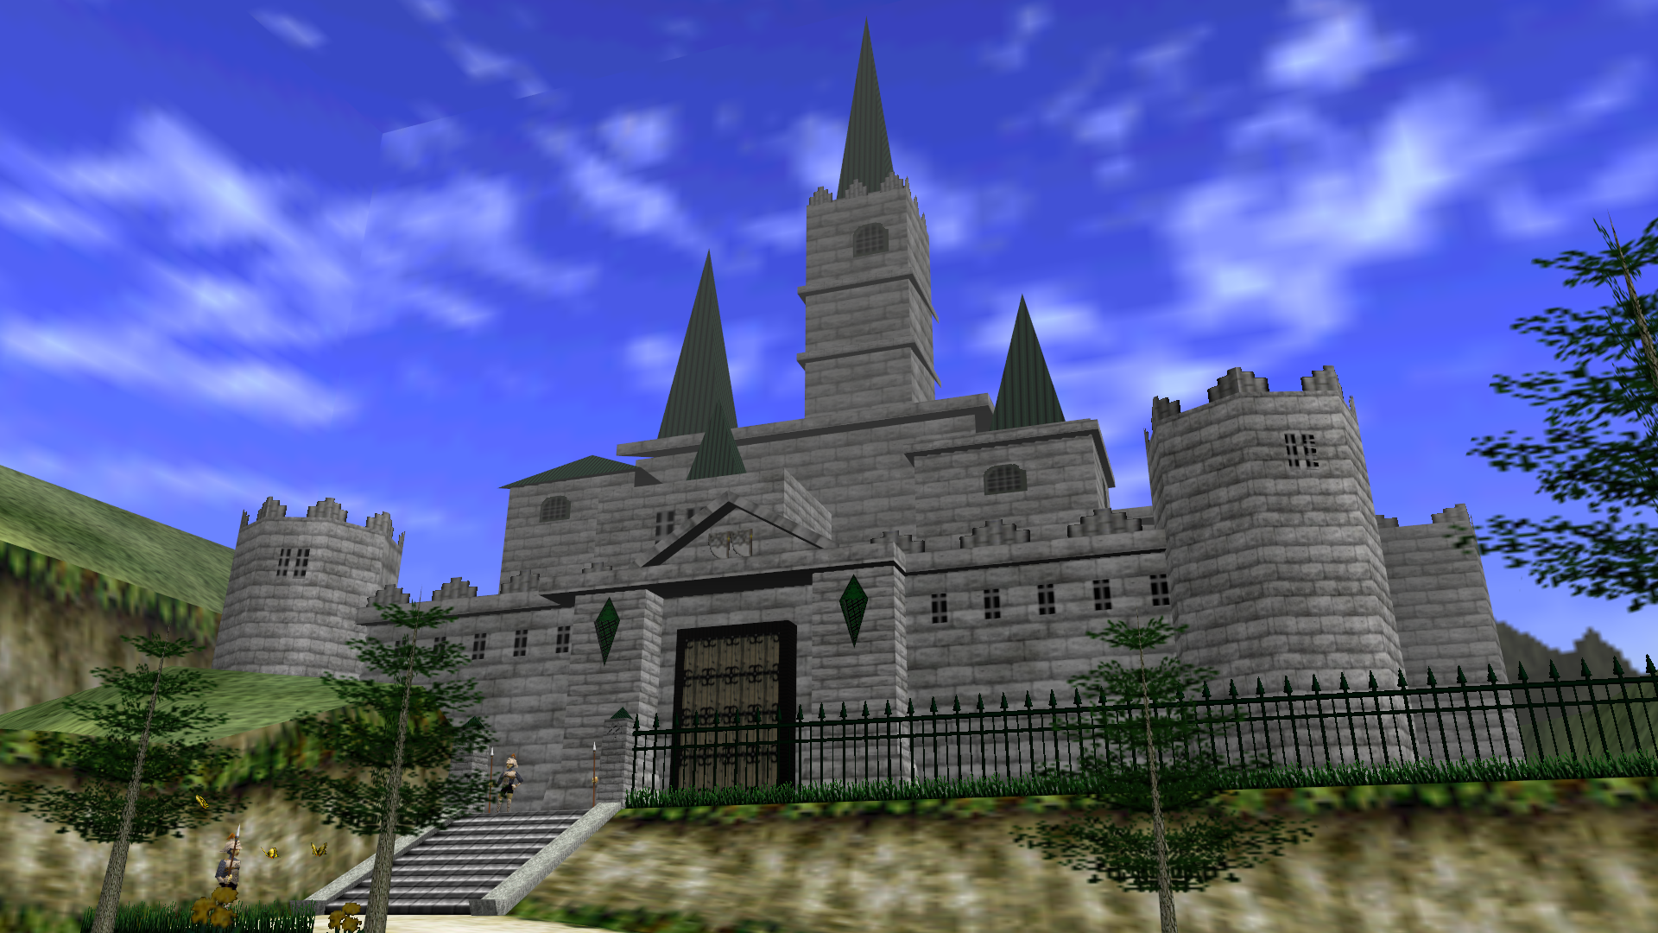

The castle Mission involves pushing back the offensive through their various walls to reach the center of the castle. Again aiming to lower their troops morale and troop count while increasing the power and amount of troops. Defense stat is lowered by the lower amount of troops. Defense is based partially by trooped count.Magic seals destruction is only way to open gates or invisible walls.

* Kill warriors and continue pushing them back farther and farther until they have no where to go
* Breaking the magical seals breaks down defenses shields. Destroys invisible wall in fortresses and castles.

Mission Progression(After Action):

* Experience gained by clearing levels, gained by soul gauge and destruction
* Attacks are the abilities unlocked based upon unit types which is shown in unit types. Plus experience based upon which units used or get kills with. Different formations, attacks.
* Level UP-Health, Speed,Power
* The troops killed can be revived for troops. 1=1 enemy for troop in terms of summons. Soul for an Soul. Differing values for light medium heavy.
* Destruction of city affects enemies morale in some way shape or form
* Goron Village- After defeated they can be a special summon. Earned for capturing each particular village. Non linear in terms of order of capturing objectives. Cave huts. They will attack on sight. Village is sectioned off once enemies are cleared in a given area they see an after action report.
* Villages connect to each other while slightly sectioned off allowing separate areas and various orders while at the same time very guided. Gather Chieftains from all villages to lower defenses for temple and fortress.